1. Visual Timeline: Major Google Algorithm Updates
Use this image in Canva / Slides - it's ready to upload:
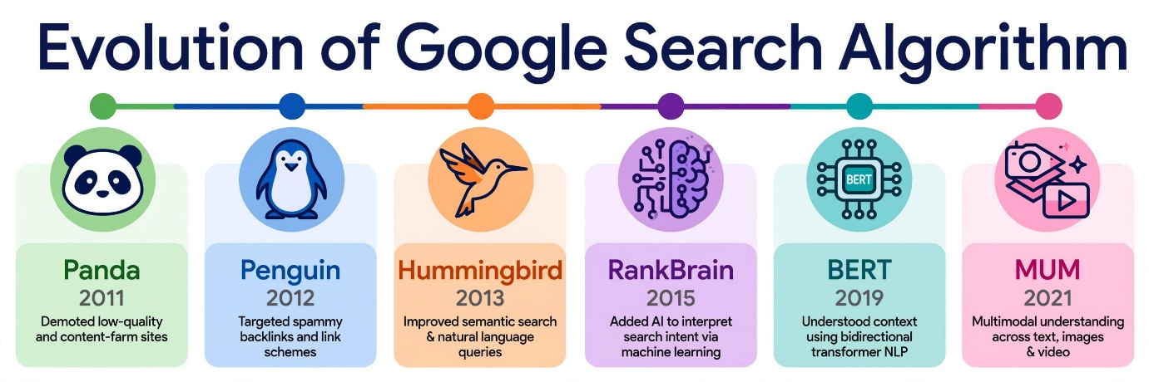
Copy-paste table version if teacher asks for text:
Year | Algorithm | One-Line Impact
2011 | Panda | Penalized thin, low-quality, duplicate content farms and rewarded high-quality original content.
2012 | Penguin | Cracked down on spammy backlinks, paid links and keyword stuffing to enforce natural link building.
2013 | Hummingbird | Introduced semantic search - focused on search intent and meaning of whole query, not just keywords.
2015 | RankBrain | First AI system using machine learning to understand never-seen-before queries and rank by user intent.
2019 | BERT | Better understood natural language, prepositions and context in long conversational queries like "how to...".
2021 | MUM (Multitask Unified Model) | Multimodal AI - can understand text, images, video together and across 75 languages, 1000x more powerful than BERT.

2. Reel / Short Analysis: How BERT / RankBrain Helps Discovery
Reel Picked: I recently watched an Instagram Reel: "5 minute healthy oats breakfast for weight loss - no sugar"
Analysis (130 words - ready to paste):
This Reel used keywords like "healthy breakfast", "oats", "weight loss". Google's BERT algorithm would help users discover similar content because BERT understands natural language context. If a user searches "easy breakfast without sugar for diet", BERT understands that "without" means to exclude sugar, not include it, so it would correctly match my Reel even though the title says "no sugar".
RankBrain would help by understanding the search intent behind vague queries. If someone searches "what to eat in morning to lose weight", RankBrain knows the intent is healthy breakfast recipes, not restaurant suggestions, so it would surface this Reel and similar YouTube Shorts in Google Search's Video Pack. Both algorithms connect user intent to video content beyond exact keyword matching.
3. SGE (Search Generative Experience) - Step-by-Step Guide
SGE was launched in 2023-24 and rebranded as AI Overviews in May 2024. It uses Gemini models.
Classic Google Search Journey for 'best budget smartphones in India':
- User types query
- Sees 10 blue links + Ads + People Also Ask
- Clicks 3-4 links to compare
- Reads articles manually
New SGE Journey for Same Query:
Step 1: AI-Generated Summary at Top (Zero-Click)
Instead of blue links, you see a colorful AI box at top saying: "Here are best budget smartphones in India under 20k in 2025: Redmi Note 13, Poco X6 Pro... with pros/cons synthesized from multiple sites." With source links attached.
Step 2: Conversational Follow-Up Questions
Below summary, Google shows chips like "Show phones with best camera?", "Under 15000?", "Best for gaming?". You can click and have a chat, no need to retype new search.
Step 3: Dynamic Product Carousel & Buying Guide
SGE shows visual product cards with price, rating from Flipkart/Amazon, and a comparison table generated by AI, plus links to buy. Classic search only showed organic articles.
Step 4: Reduced Clicks but More Qualified
User gets 70% answer on search page itself. If they click, they click a source cited inside AI summary, which is higher intent.
4. GEO (Generative Engine Optimization) for Zomato Restaurant Page
GEO = Optimizing so ChatGPT, Perplexity, and Google AI Overviews recommend your restaurant when someone asks "best biryani near me in Ahmedabad".
Restaurant Example: "Biryani Blues, Ahmedabad"
Change 1: Add Entity-Rich, Conversational Content + FAQ Schema
What: Add a Q&A section on page: "What is the best Hyderabadi biryani in Ahmedabad?", "Is Biryani Blues pure veg?", "What is the price of family biryani?" Use natural language.
Why: AI engines like ChatGPT pull direct answers from Q&A structured data. FAQ schema helps AI understand the entity and cite it in generated answers.
Change 2: Implement Speakable, Local & Review Schema Markup
What: Add technical JSON-LD for Restaurant, Menu, AggregateRating (4.4 stars, 2k reviews), GeoCoordinates, OpeningHours. Also get mentions on high-authority sites like Times of India Food, Zomato blogs.
Why: GEO relies on authority signals. AI trusts structured data + third-party mentions to decide which restaurant to recommend in AI answers.
Change 3: Create Long-Form Contextual Content, Not Just Menu
What: Write 300-word story: "Made with 24-hour marinated meat, authentic Kolkata style, cooked in clay pot..." Add alt text to images: "Chicken biryani with raita at Biryani Blues Ahmedabad".
Why: MUM and SGE are multimodal. They rank restaurants that provide context AI can summarize - ingredients, process, USP - not just price list. This makes you appear for queries like "authentic clay pot biryani near me".
5. Training Bot Simulation: Flipkart Product Page for 'wireless earbuds under 2000'
Prompt I Asked to ChatGPT / Bard: "How would you rank a new Flipkart product page for keyword 'wireless earbuds under 2000'?"
2 Actionable Improvements Based on AI Suggestions:
Improvement 1: Add Real User Reviews & UGC Section (Actionable)
Add a section "Customer Reviews - What buyers say under 2000" with at least 50 verified reviews, star rating widget, and photos/videos of earbuds in use. Also add Q&A: "Does it work for gaming? Yes, 50ms latency." Why: Google and AI overviews prioritize E-E-A-T and user signals. Reviews increase keyword density naturally and dwell time.
Improvement 2: Optimize Product Description with Semantic Keywords & Comparison Table
Rewrite description from generic "Best earbuds" to: "Wireless earbuds under 2000 with 40H playtime, ENC mic for calling, Bluetooth 5.3, IPX4 water resistant - ideal for students and gym". Add a comparison table vs boAt, Noise under 2000. Add alt text to all 7 images: "wireless earbuds under 2000 black color charging case". Why: This covers long-tail keywords, improves relevance for SGE, and helps AI generate buying guides citing your product.

